Name:
Course:
Professor:
Date:
Lighting installation and fault finding
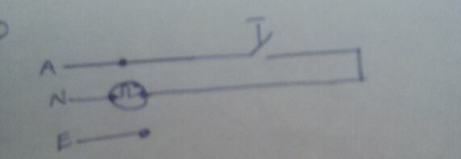
- a). One-way circuit – it’s a simple circuit that allows one circuit to be turned on and off with one switch.

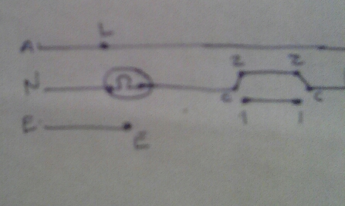
b). Two-way – enables one circuit to be turned on or off by either of two switches.

c). Multiple-way – used when one circuit is to be turned off or on by three or more switches.
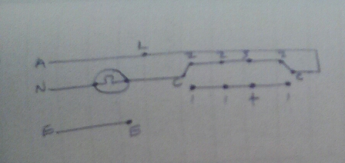

d). Dimmer control – they are used to control the manner in which a room is lit.
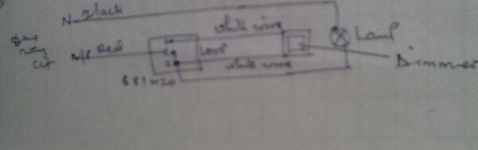

e). occupancy sensor control – they are used to replace the conventional lighting switches by using a timer switch.
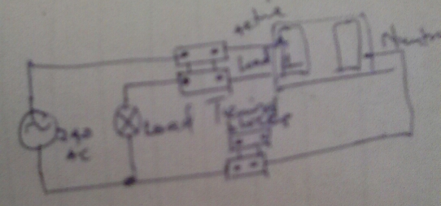

Scenario | Area | Lux level required and reason for selection (lumen/m²)
Kitchen/dining | Island | 100, because the area is receiving quantity of light.
Kitchen/dining | Kitchen counter | 500, enough lighting is required for precision
Kitchen/dining | Dining area | 150, the area is used regularly, thus enough lighting required
Kitchen/dining | General | 50, visual tasks performed occasionally.
Courtyard | Barbecue | 500, enough lighting required for outdoor activities.
Courtyard | Seating arrangement | 300, enough light required to address the shadows
Courtyard | General | 50, lighting required occasionally.
b). line, color, shape, form, value, space, & texture.
c).
Symbol | Specification (lumen/m²)
- Kitchen counter | 500
- Island | 100
- Dining area | 150
d).
Symbol | Specification (lumen/m²)
- Barbecue | 500
- Sitting arrangement | 300
- General | 50

Diagnostic step | Associated technique
Observe behavior | Gather information using senses and list the observations.
Define the problem area | This allows elimination of areas working properly
Identify possible causes of the fault | Every component is analyzed to identify all causes of malfunction
Determine probable cause | Determine the probability of why the fault areas are not working
Test and repair
- a).
Type of work | Competency requirement
Single-phase appliances | Be familiar with single phase electrical loads
Three phase appliances | Be familiar with three phase electrical loads
Replacement of accessories and fittings | Understand the relationship between different accessories
Installations | Have necessary expertise in installations
Certificate of compliance | Comply with AS/NZS3000 requirements
Electrical safety certificate | Understand the relationship between electrical circuits
Verification | Operate under AS/NZS3000 requirements
b). No
c). yes
- when unsuitable luminaires are used, there can be glare which may lead to adaptation to bright light, thus inability to see in dull lighting, lead to eye damage due to poor lighting quality, can cause shadows in working areas, may have reduced illuminance, and quick degradation of the lighting equipment.

